**冯楷翔第七+八次上机训练**

**1**

**ppt**

**图表常用设置**

|  |  |
| --- | --- |
|  |  |

|  |  |
| --- | --- |
|  |  |

|  |  |
| --- | --- |
|  |  |

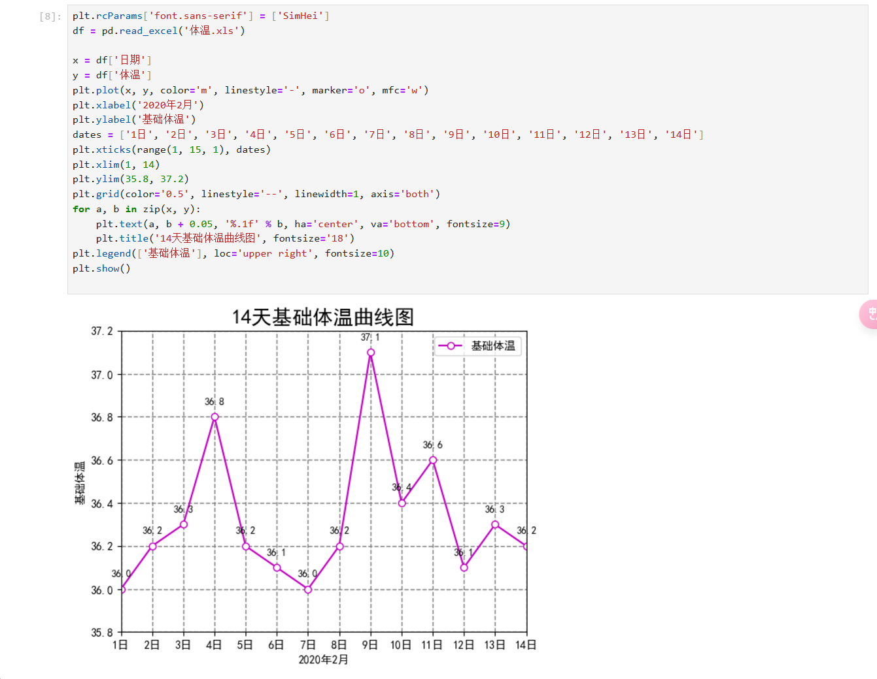

**常用图表绘制**

|  |  |
| --- | --- |
|  |  |

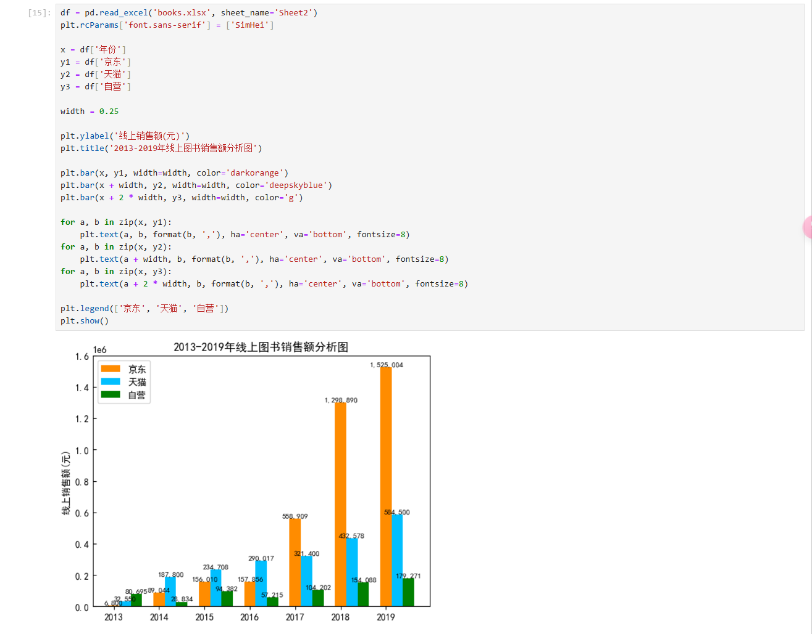

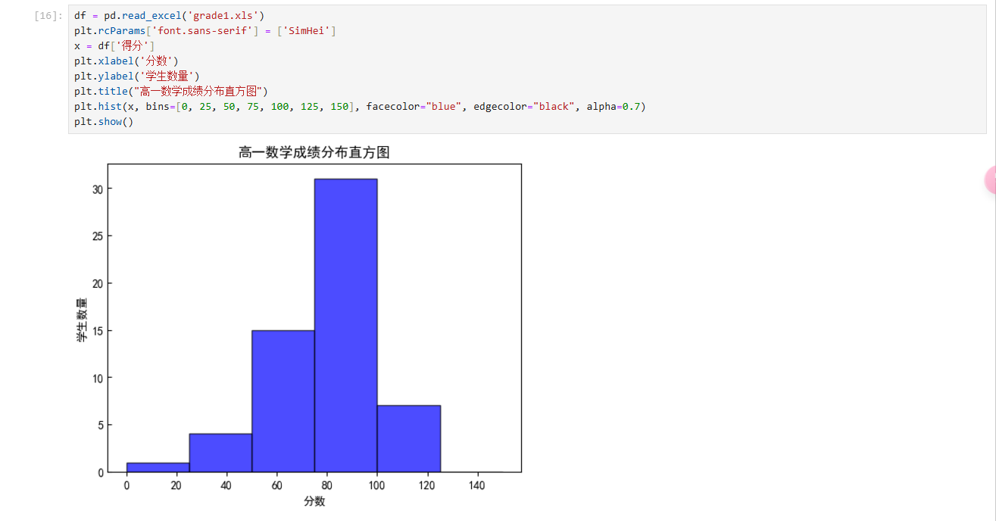

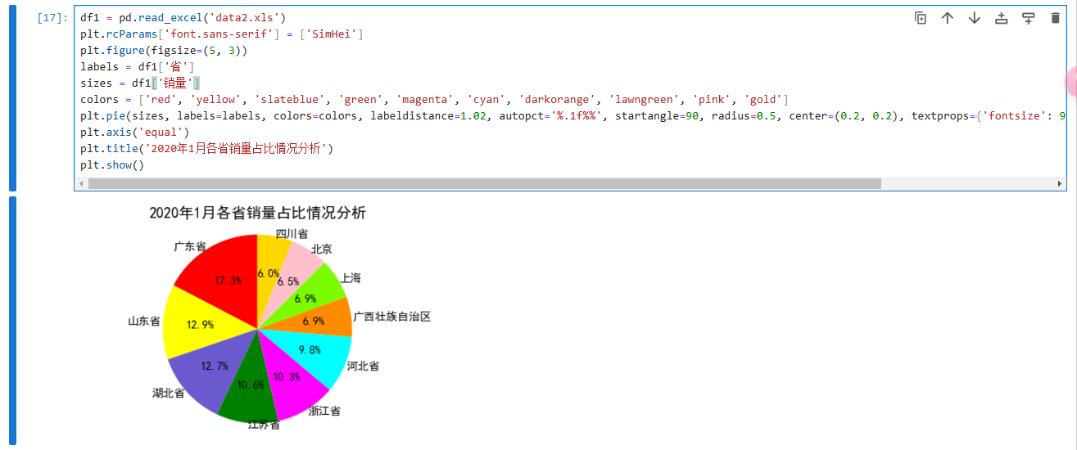

|  |  |
| --- | --- |
|  |  |

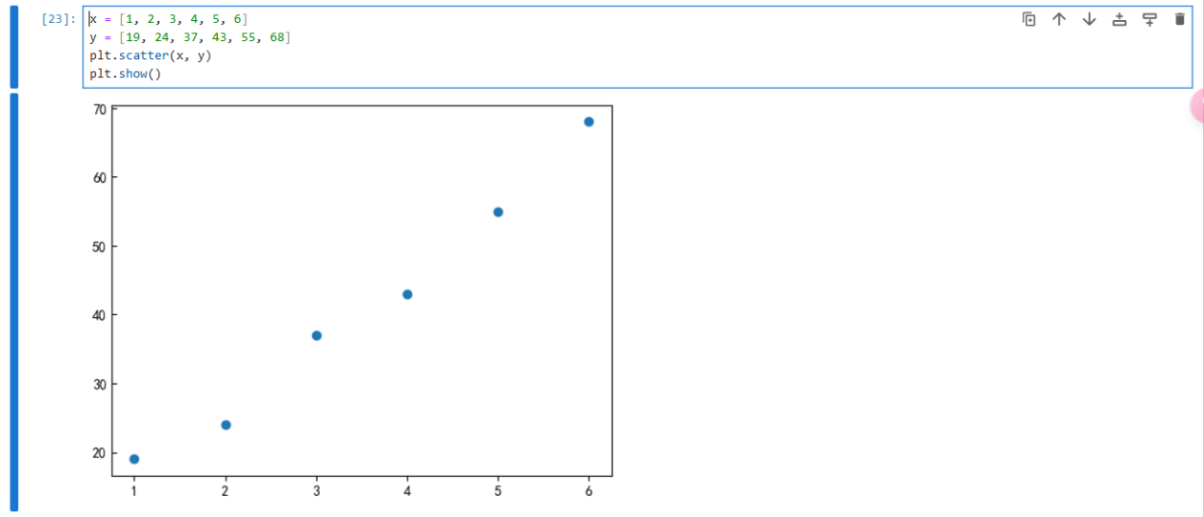

|  |  |
| --- | --- |
|  |  |

|  |  |
| --- | --- |
|  |  |

|  |  |
| --- | --- |
|  |  |

|  |  |
| --- | --- |
|  |  |

**作业题**

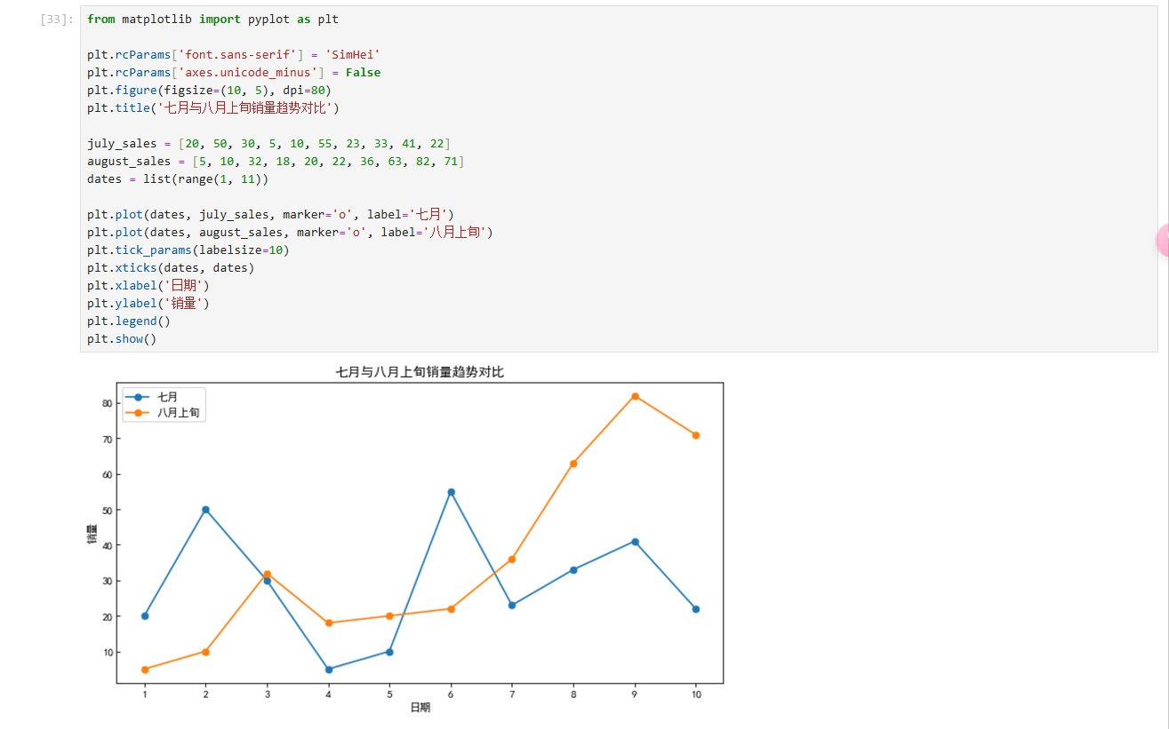

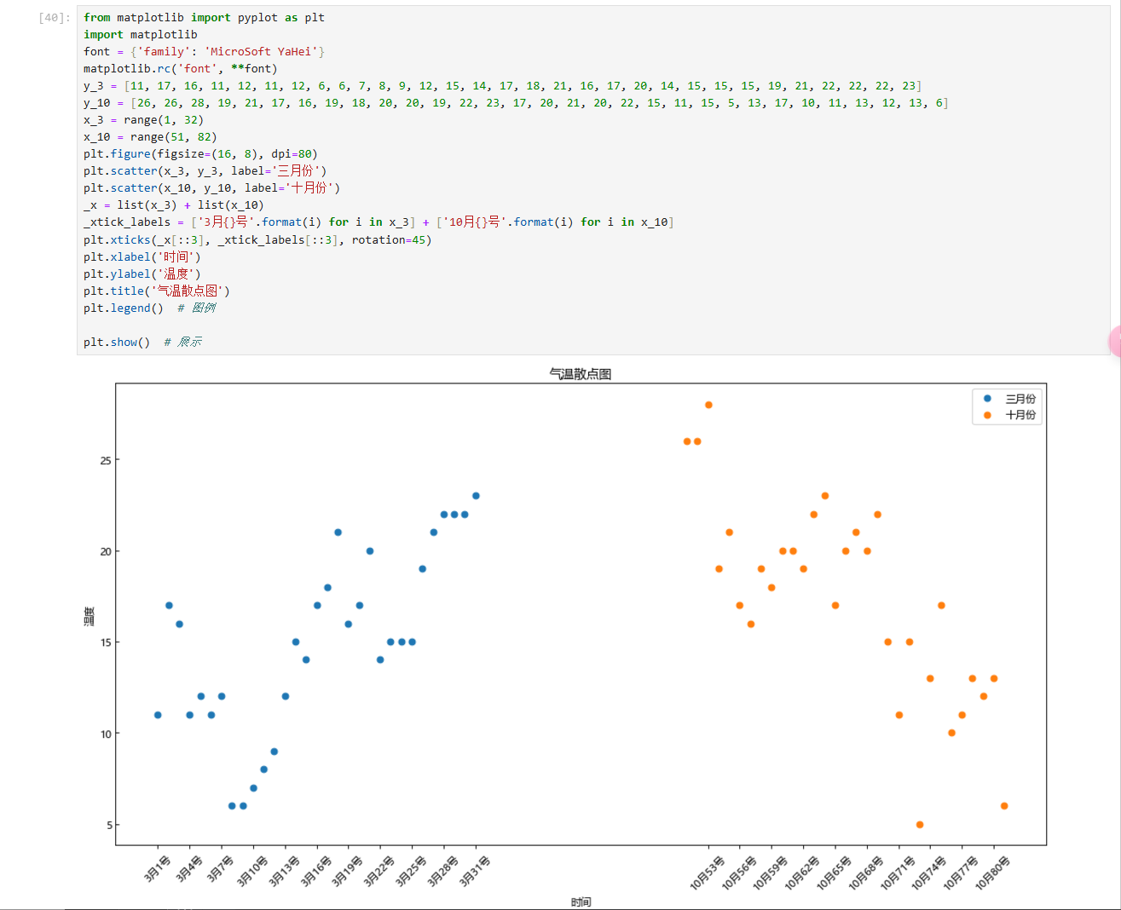

**2**

**Ppt**

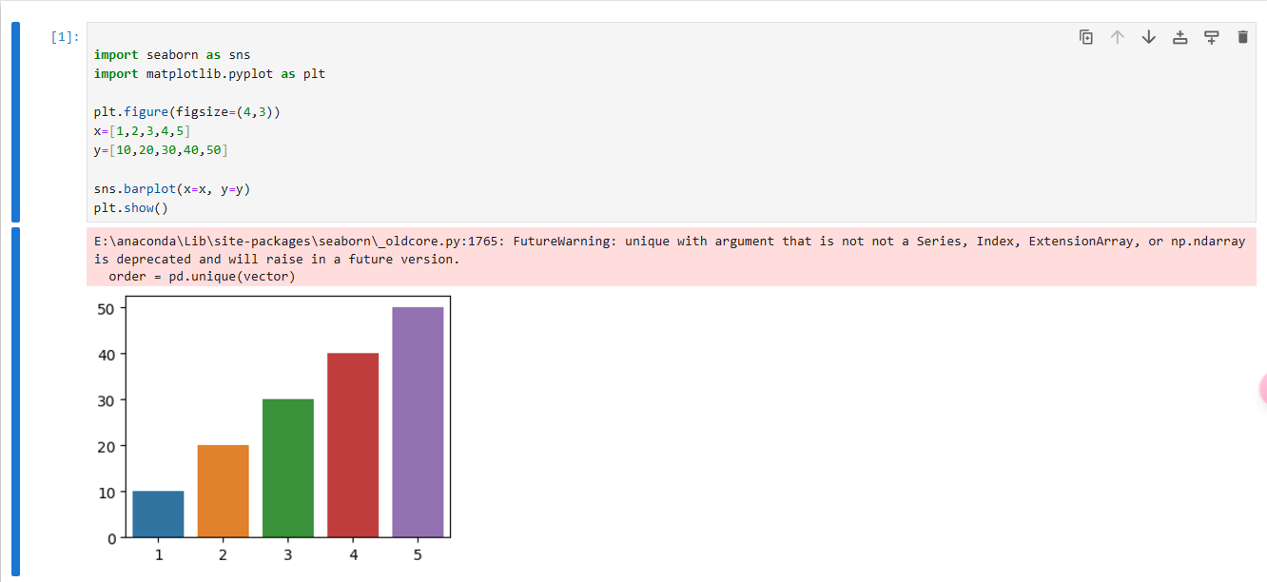

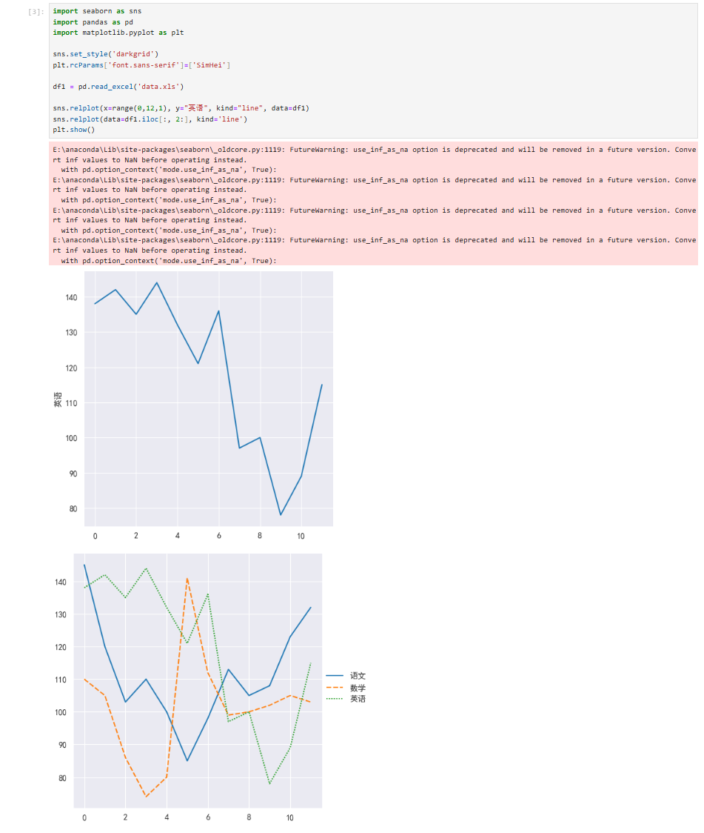

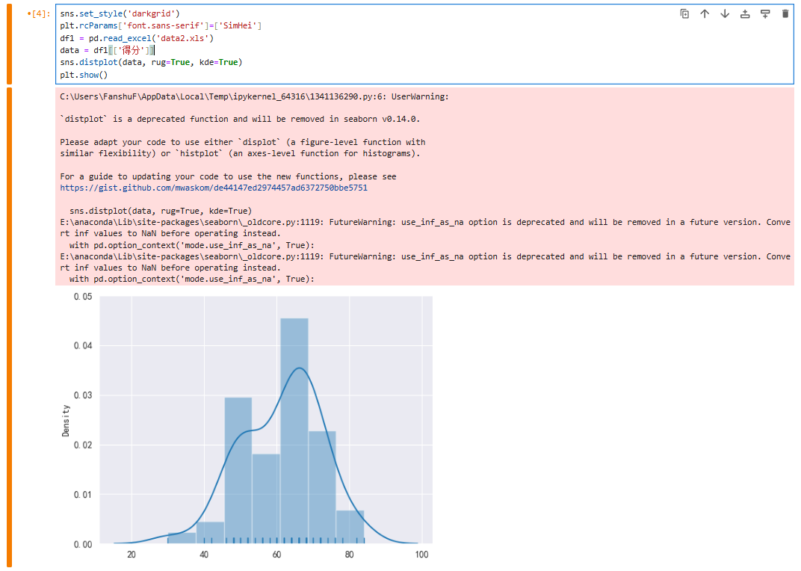

|  |  |
| --- | --- |
|  |  |

|  |  |
| --- | --- |
|  |  |

**作业**

